DIGITAL THERMOMETER

Introduction:
A thermometer is a scientific instrument used to measure temperature. Temperature indicates the degree of hotness or coldness of an object or environment. Thermometers are widely used in medical, industrial, laboratory, meteorological, and domestic applications.

History of Thermometer :
- 1593 – Galileo Galilei invented an early thermoscope
- 1714 – Daniel Gabriel Fahrenheit developed the mercury thermometer
- 1742 – Anders Celsius introduced the Celsius scale
- Modern Era – Digital and infrared thermometers replaced mercury due to safety concerns

Types of Thermometers:

Liquid-in-Glass Thermometer
- Mercury thermometer
- Alcohol thermometer

Digital Thermometer
- Uses electronic sensors
- Fast and accurate

Infrared Thermometer
- Measures temperature without contact
- Common in medical screening

Bimetallic Thermometer
- Used in industrial equipment

Gas Thermometer
- Highly accurate, used in laboratories

Overall View of Common Thermometers:
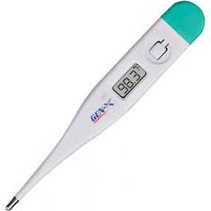

Main Components of a Thermometer:

Liquid-in-Glass Thermometer Components
- Bulb – Contains mercury or alcohol
- Capillary Tube – Narrow tube for liquid expansion
- Glass Stem – Encloses the capillary
- Scale – Graduated markings (°C / °F)

Digital Thermometer Components
- Temperature Sensor (Thermistor)
- Microcontroller
- Display (LCD/LED)
- Battery
- Plastic Casing

Internal Components of a Digital Thermometer:
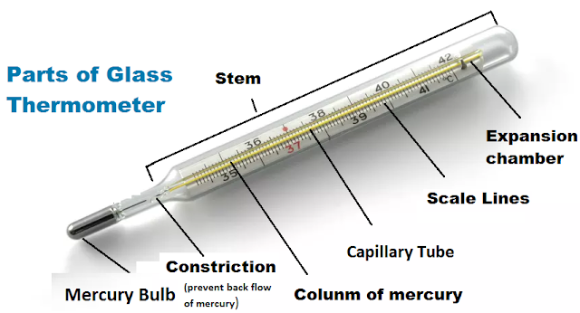

Working Principle of Thermometer:

Electronic thermometers detect temperature changes using a thermoresistive device in which the electrical resistance changes in response to changes in temperature

Working of Liquid-in-Glass Thermometer
- Temperature change causes expansion or contraction of liquid
- Liquid rises or falls in the capillary tube
- Temperature is read from the scale

Working of Digital Thermometer
- Sensor detects temperature
- Converts temperature into electrical signal
- Microcontroller processes data
- Result is shown on digital display

Workflow of a Digital Thermometer:



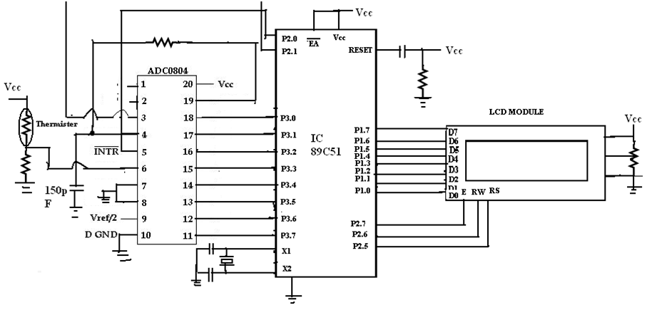

Workflow Steps:
- Sensor contacts object/body
- Temperature change detected
- Electrical signal generated
- Signal processed digitally
- Temperature displayed on screen

Applications of Thermometer:
- Medical diagnosis
- Weather forecasting
- Industrial process control
- Food safety
- Laboratory experiments

Advantages and Disadvantages

Advantages
- Accurate temperature measurement
- Easy to use
- Portable (digital types)

Disadvantages
- Mercury thermometers are hazardous
- Digital thermometers require batteries

Safety Precautions
- Do not break mercury thermometers
- Dispose of damaged thermometers properly
- Avoid exposure to mercury vapor

Conclusion
The thermometer is a vital instrument used in everyday life and scientific applications. With advancements in technology, digital and infrared thermometers have improved accuracy, safety, and convenience, making temperature measurement faster and more reliable.

